**Name: Chandrasekaran R**

**Practice: Impact Trainee**

**Designation: Trainee**

**Azure Storage Account**

**Step 1**: Open Storage Account. Click-> create.

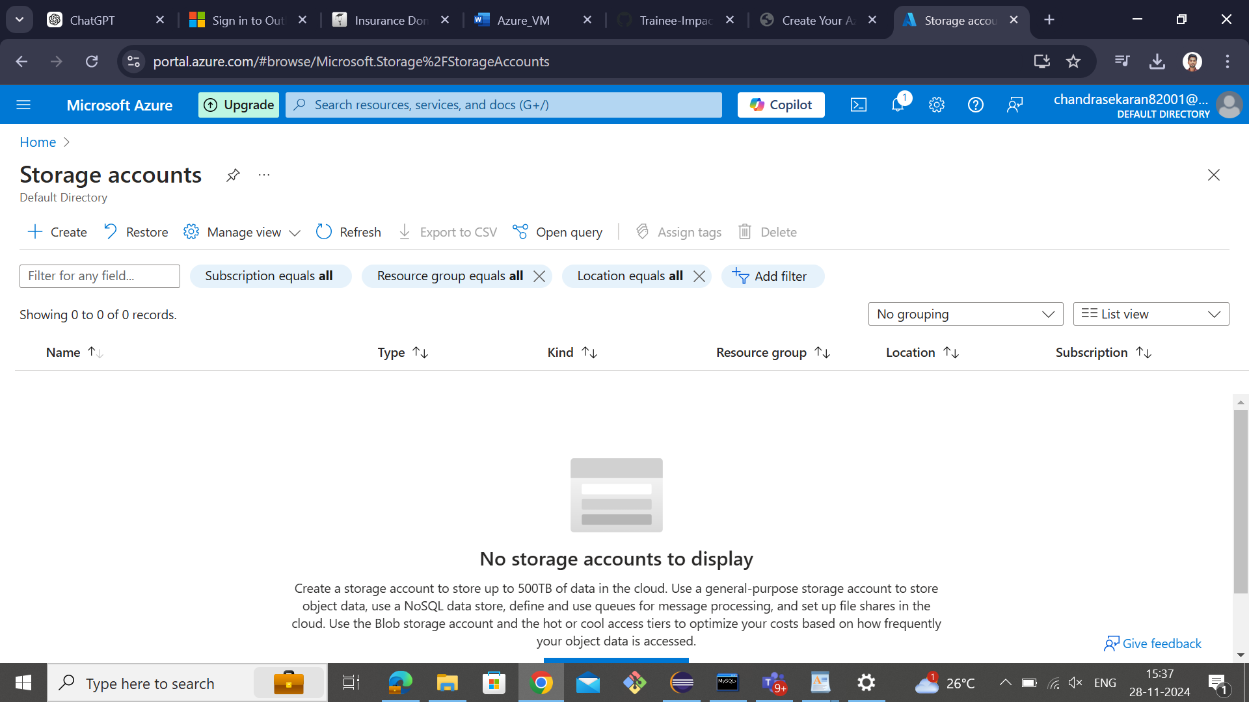

**Step 2:** Create or select Resource group.

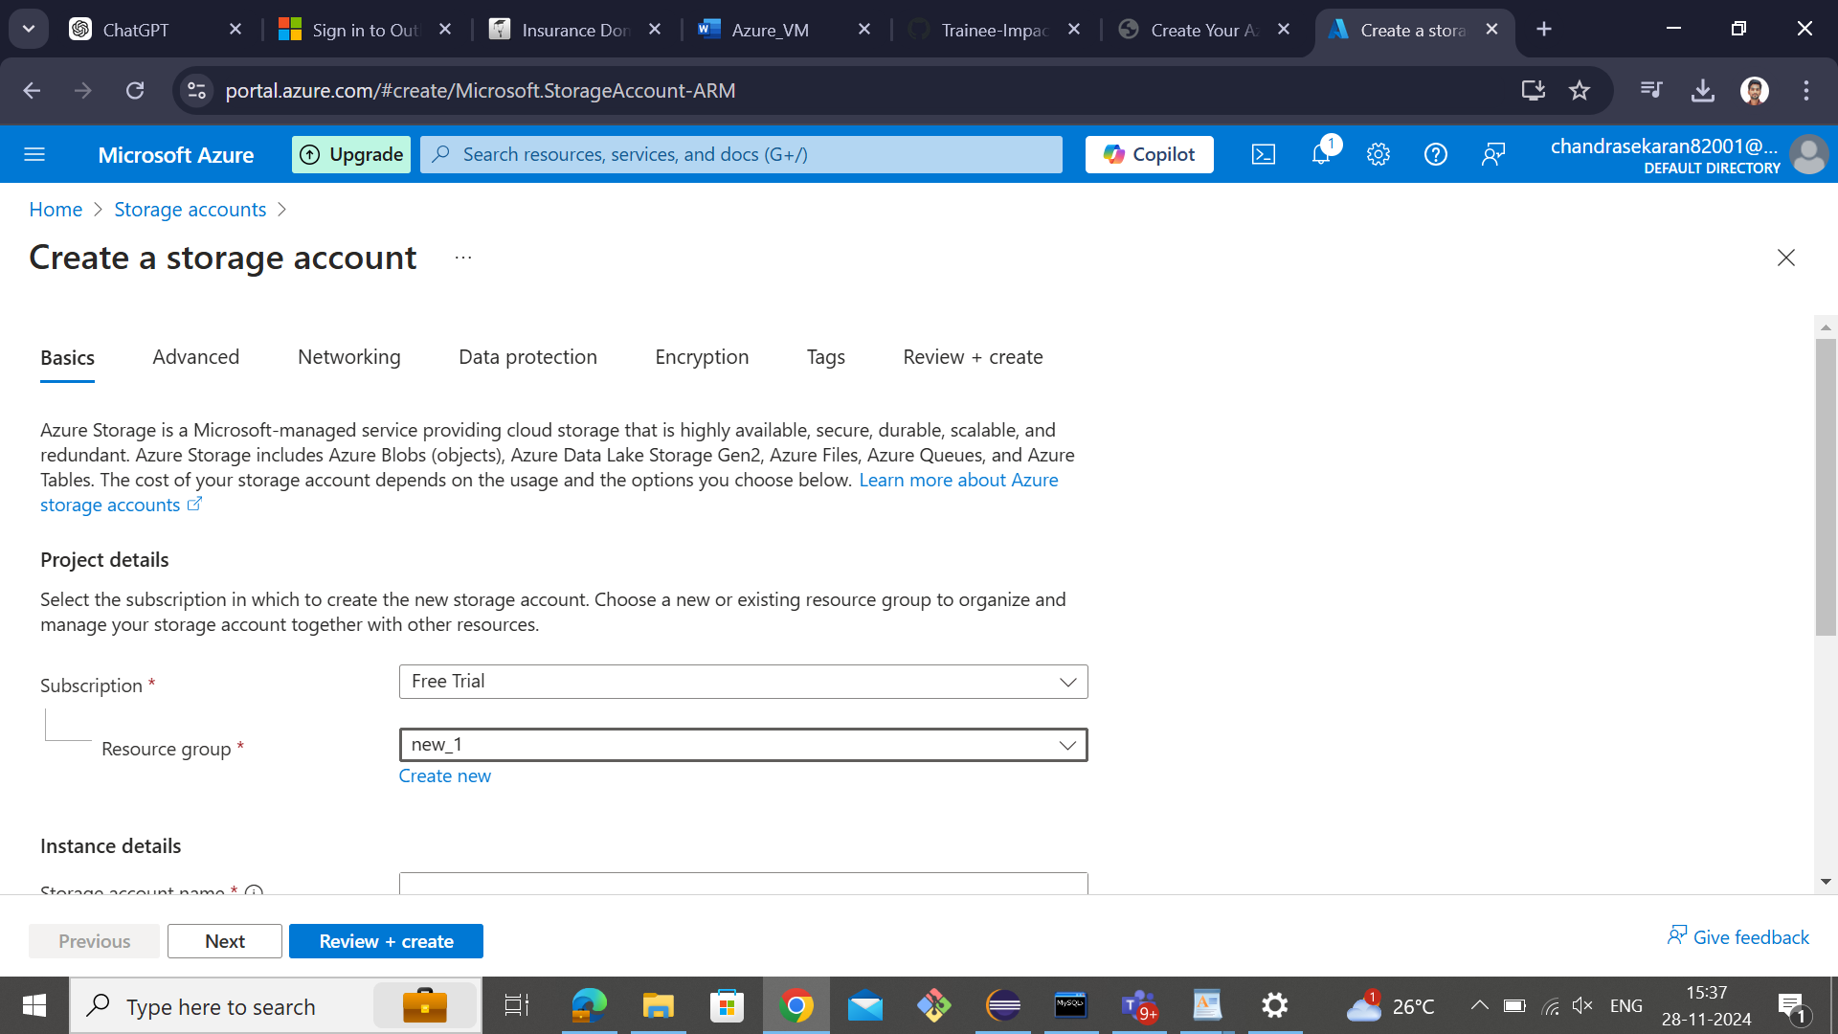

**Step 3:** Type, Storage account name and select Region.

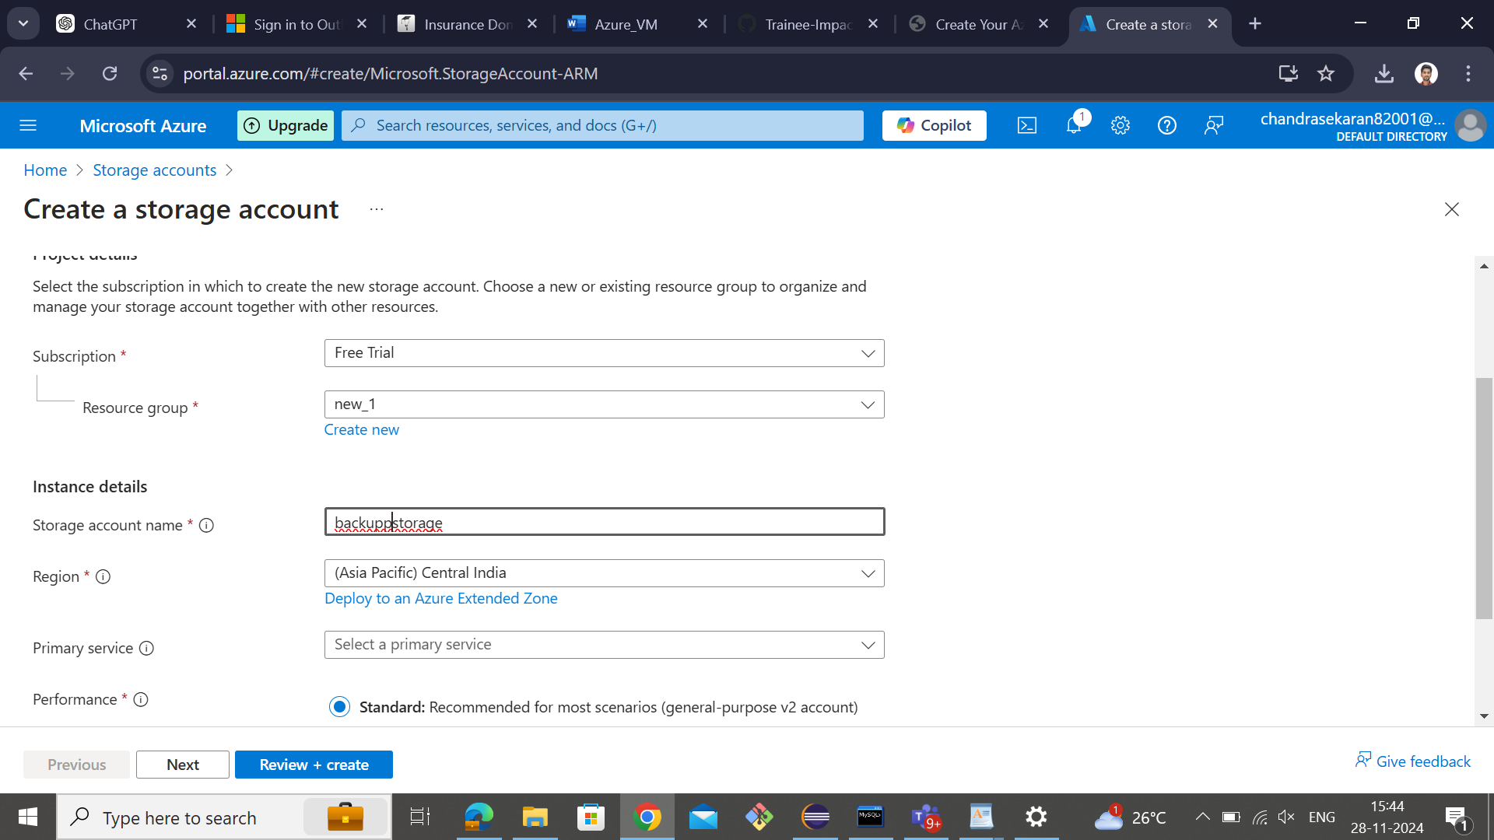

**Step 4:** select primary service.

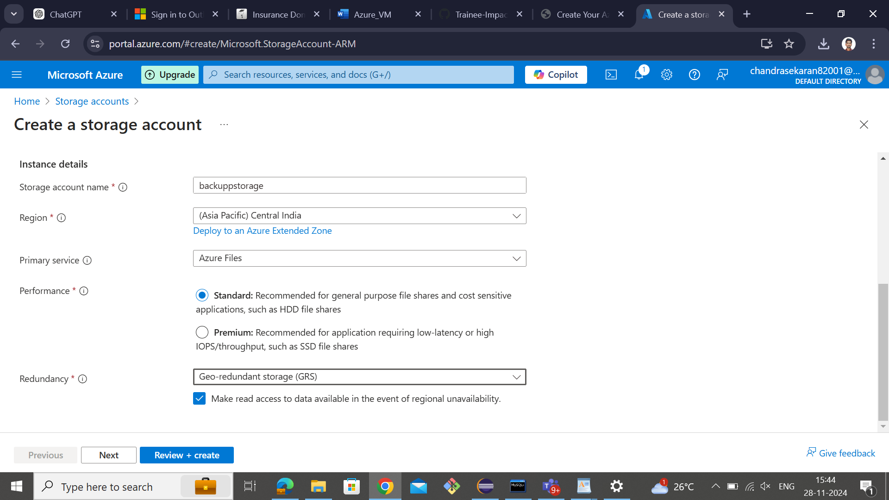

**Step 5:** In Advance tab, select the check box based on the requirement.

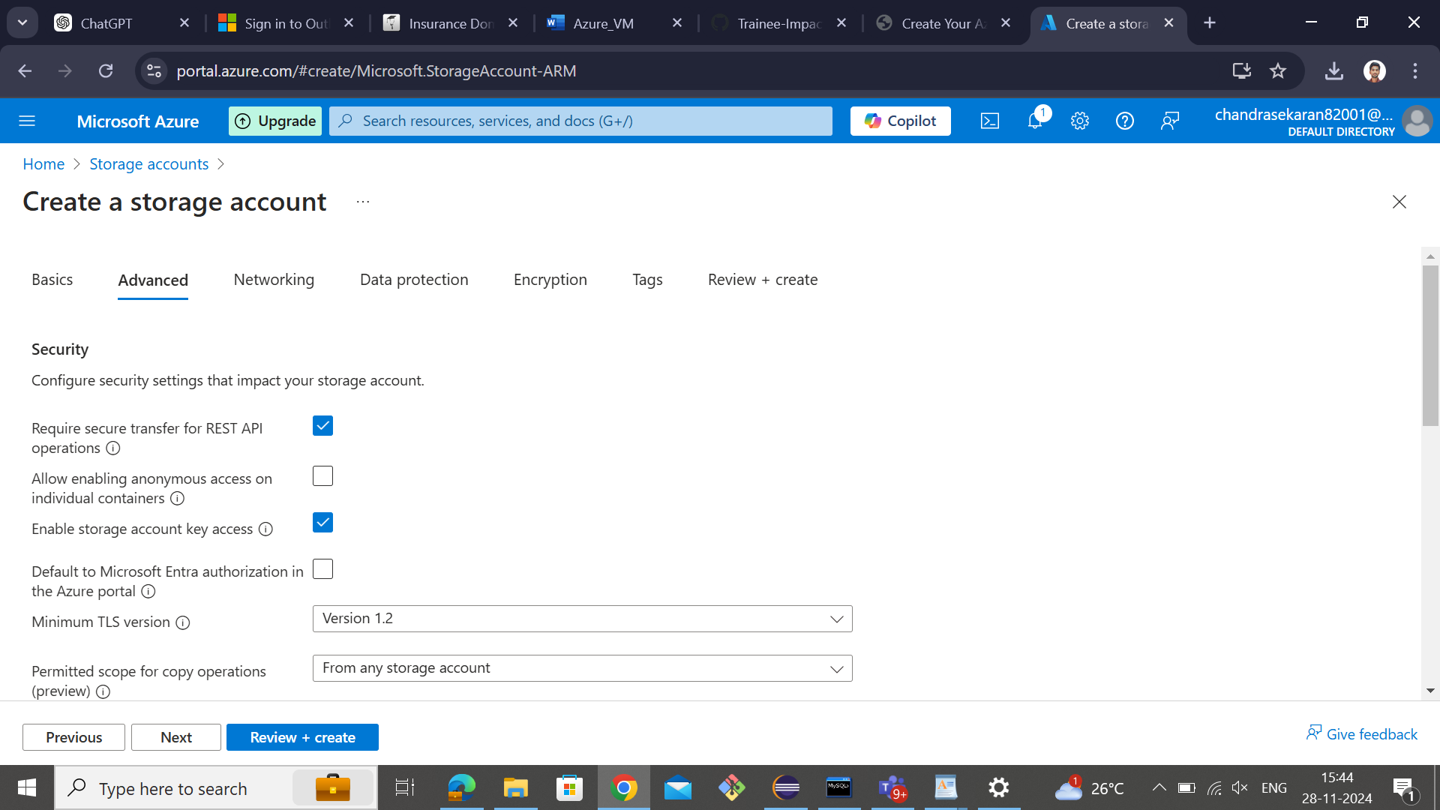

**Step 6:** select Access tier -> based on your access to the file stored in account.

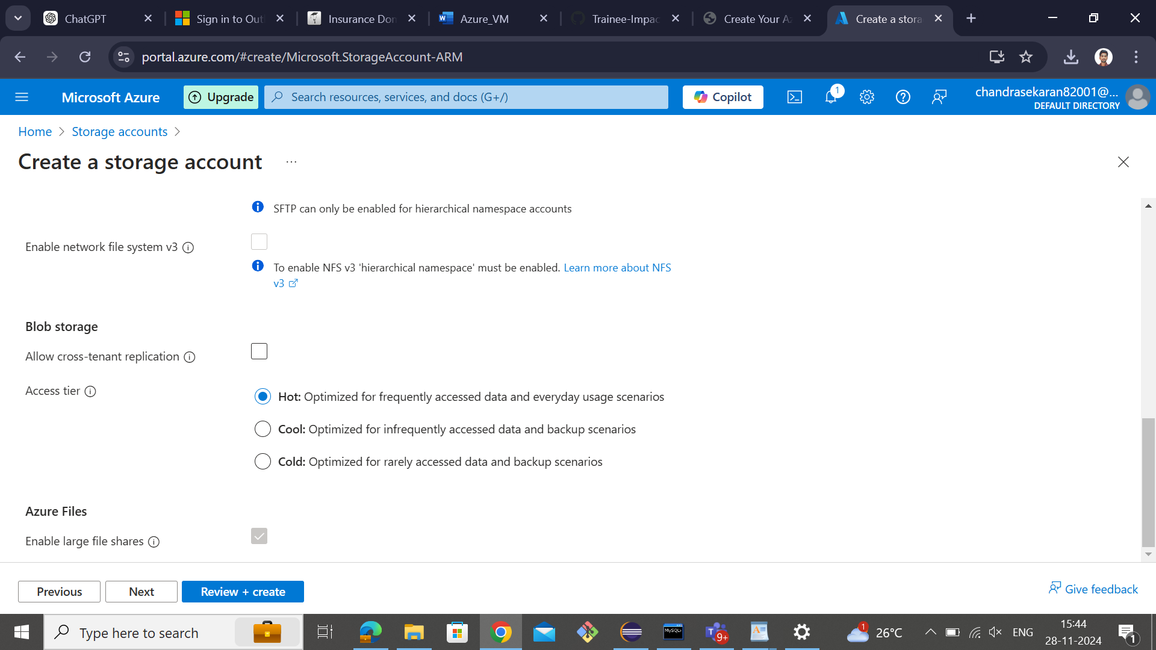

**Step 7:** In the Network tab, you need to give access for who are all access your files.

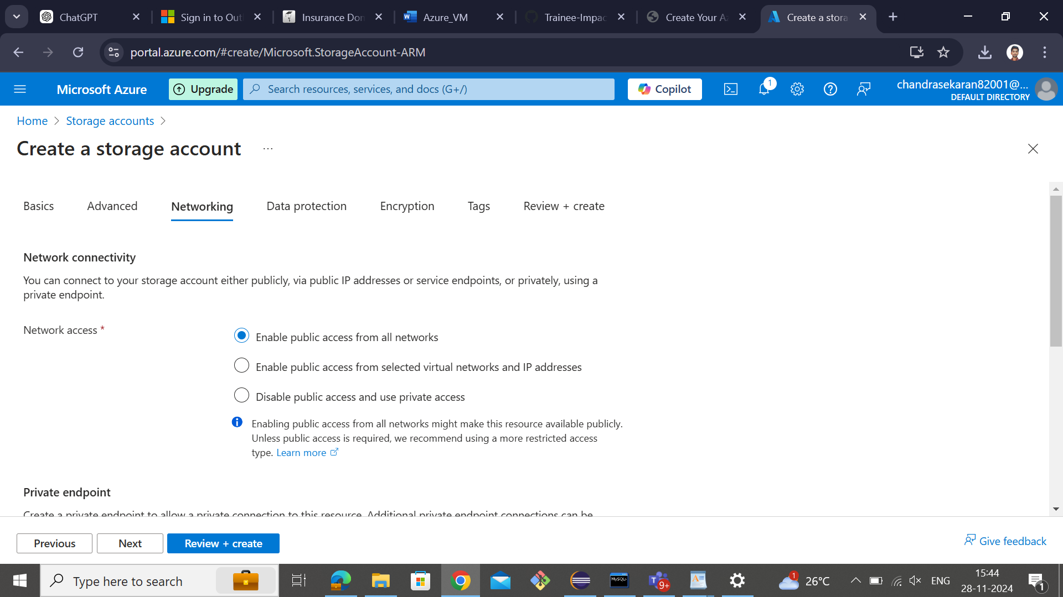

**Step 8:** If you want to create private files. Create and add private endpoint.

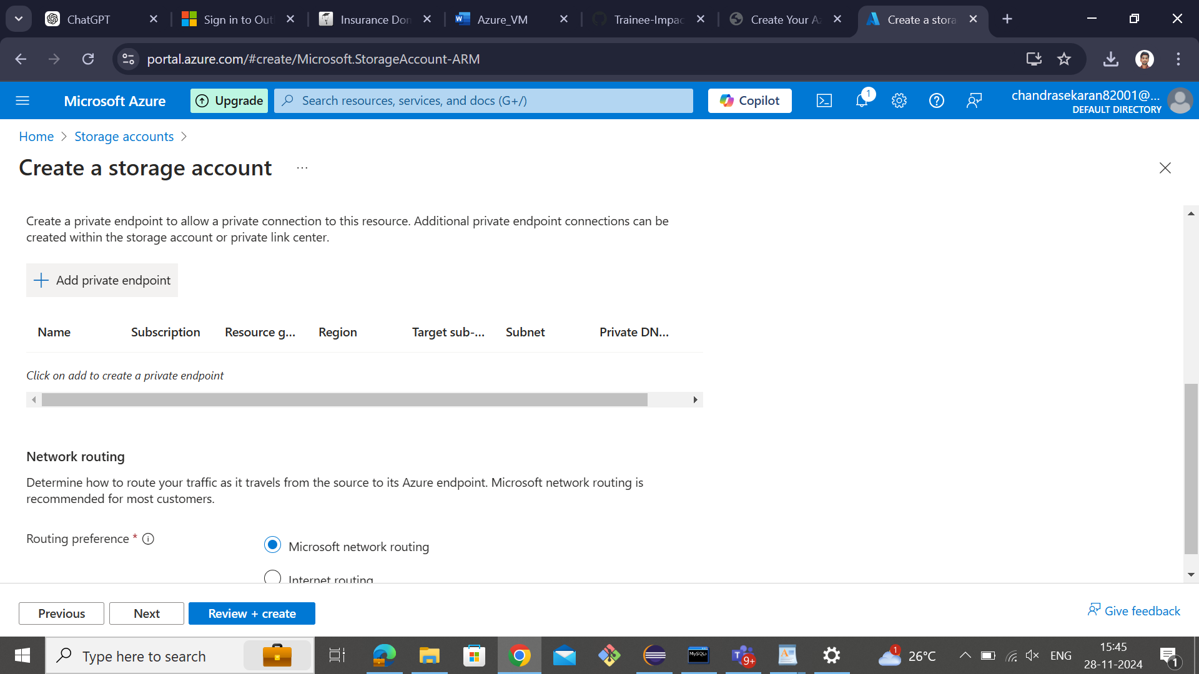

**Step 9:** In data protection, choose which protection you need for your files.

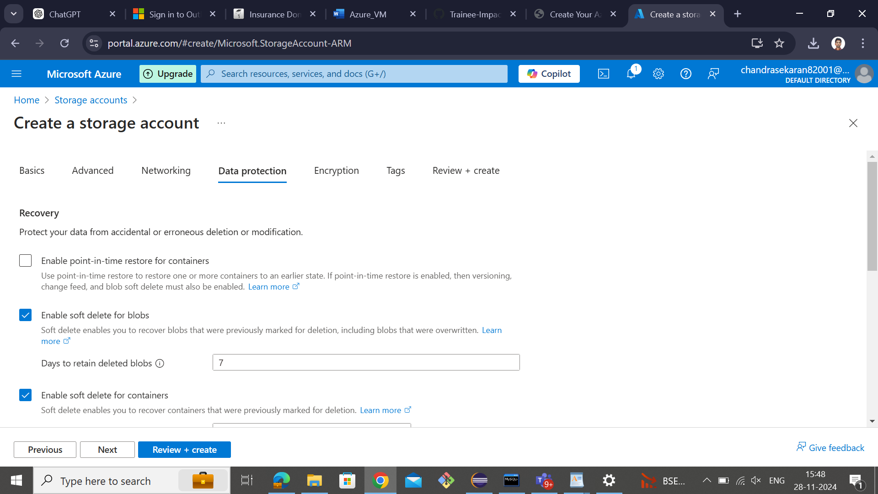

**Step 10:** If you want to enable versioning. Here you can select the check box for the enabled versioning.

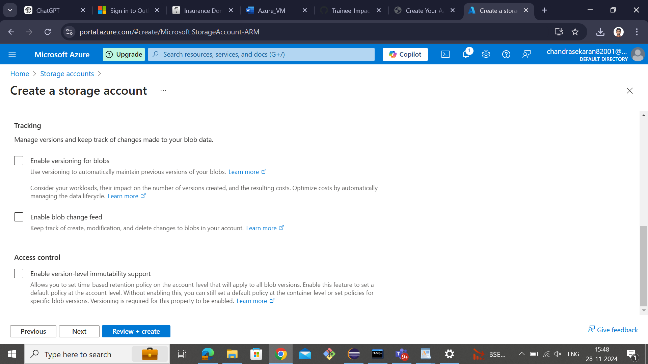

**Step 11:** If you want encryption for your storing data. Then here select encryption type for your storing data.

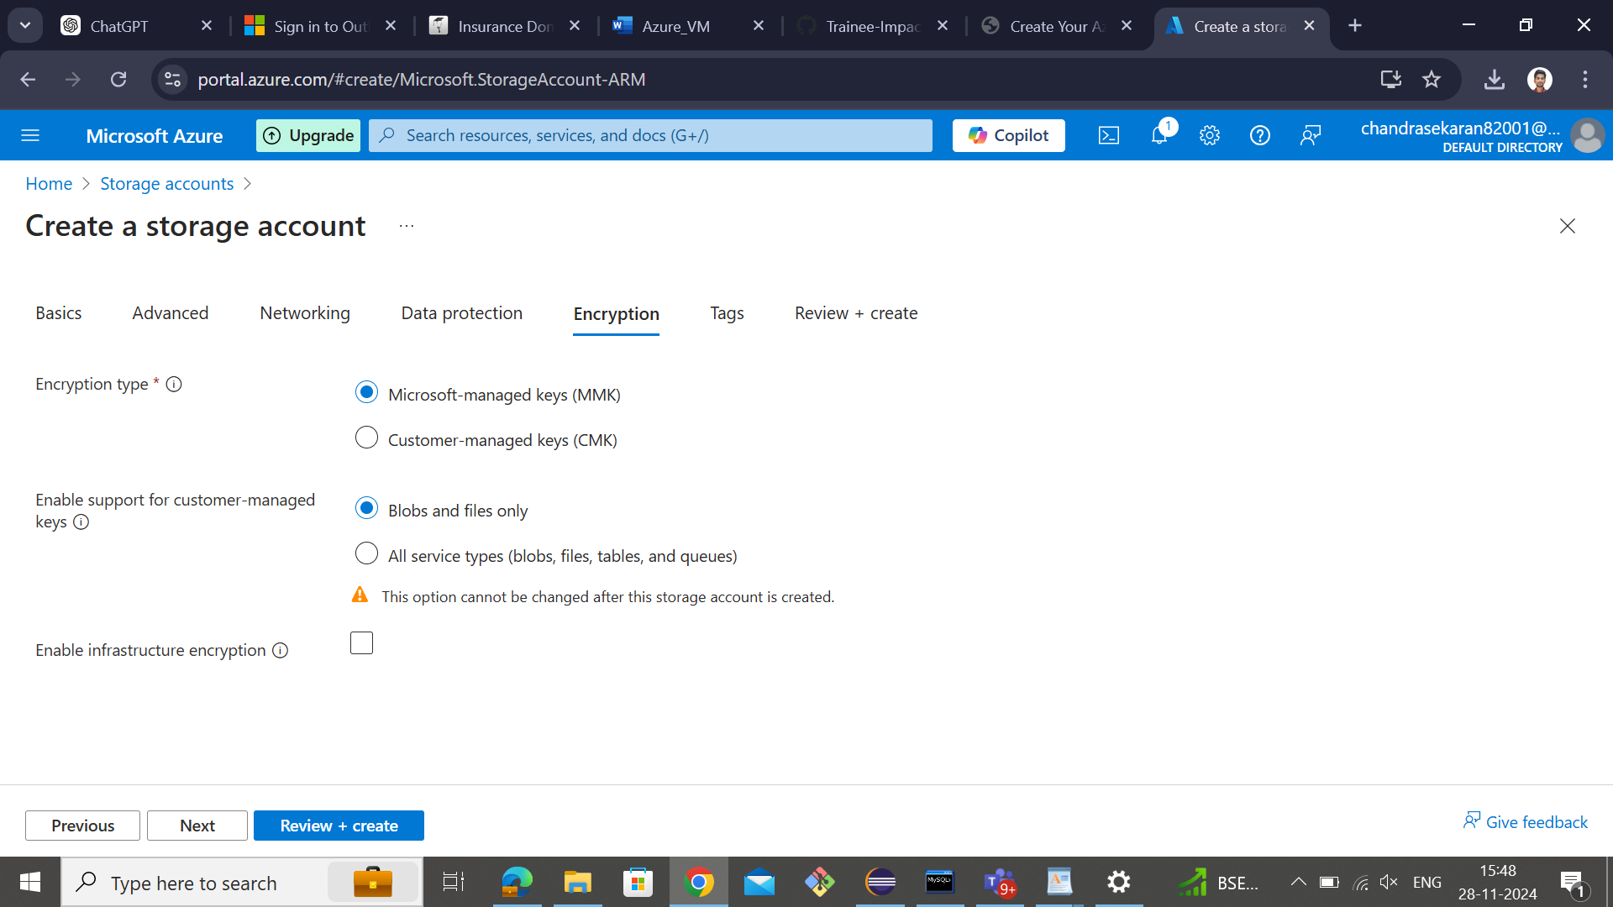

**Step 12:** It is optional. If you want to identify the created storage account uniquely it means you can use this.

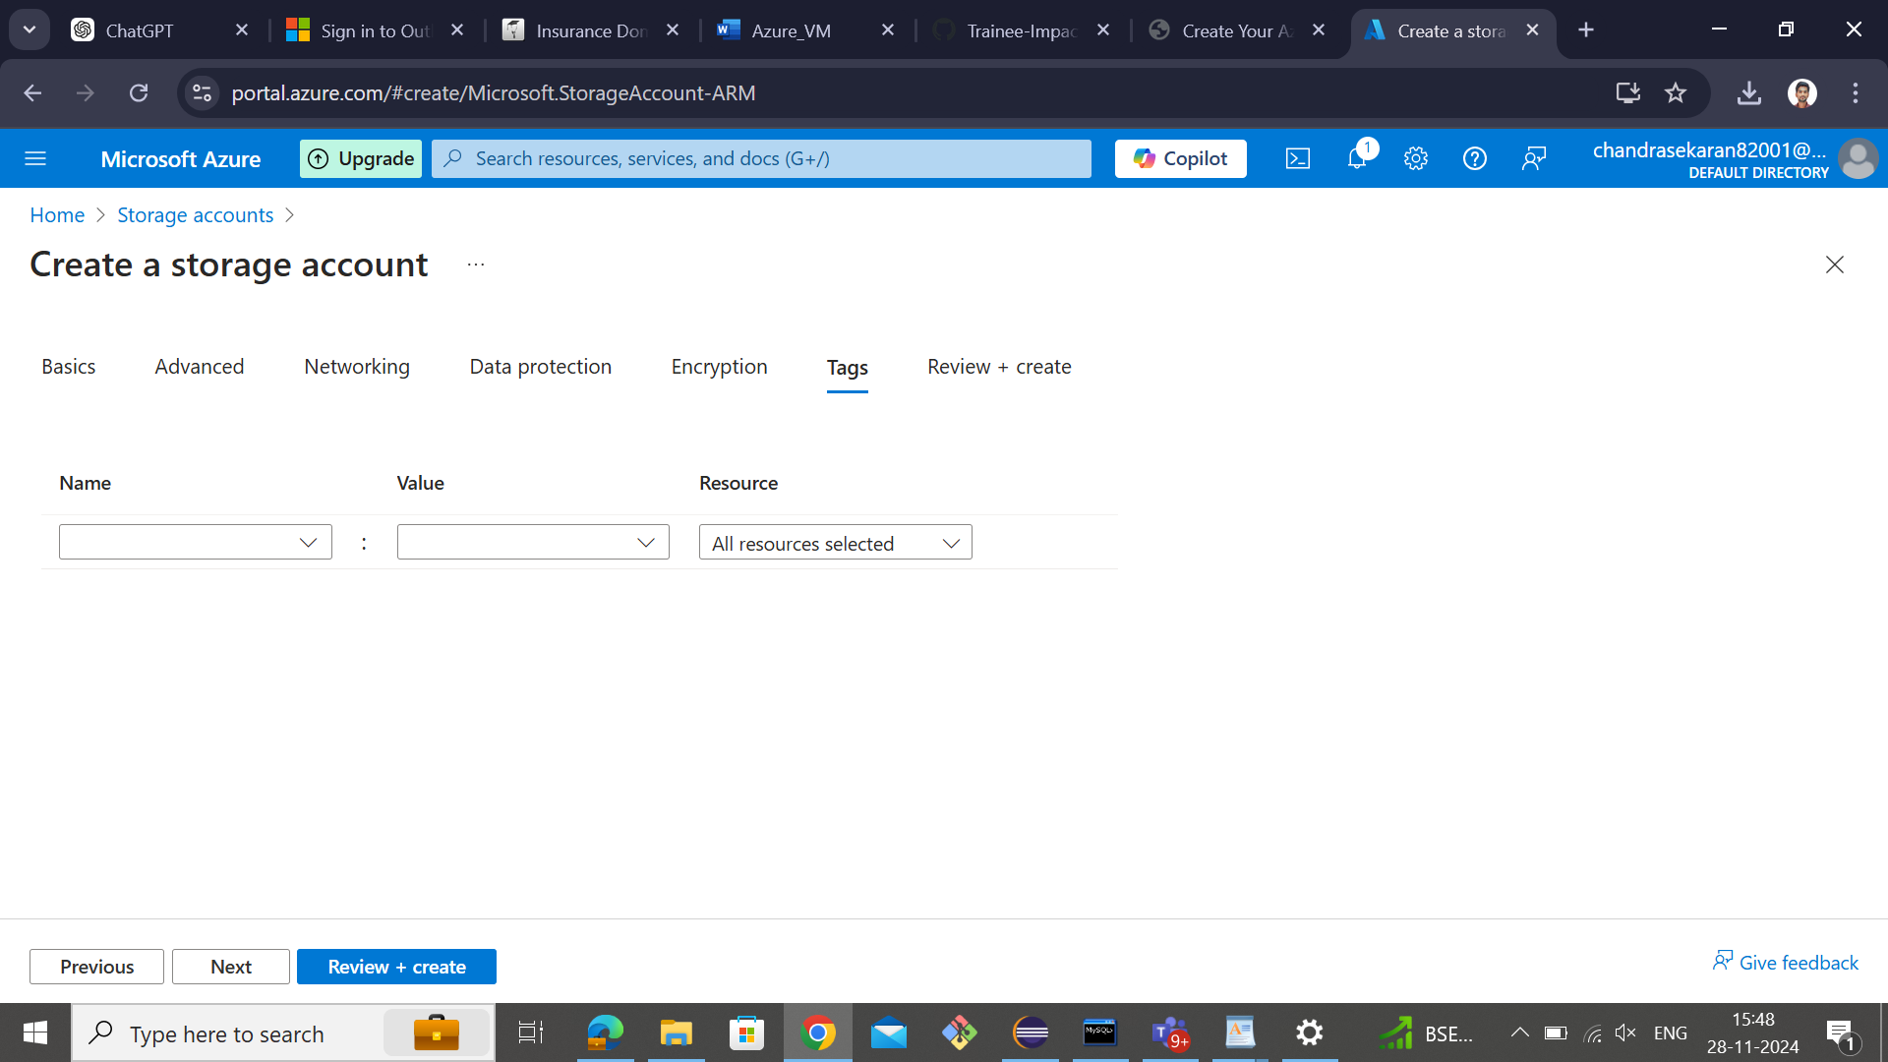

**Step 13:** After reviewing all stages -> create.

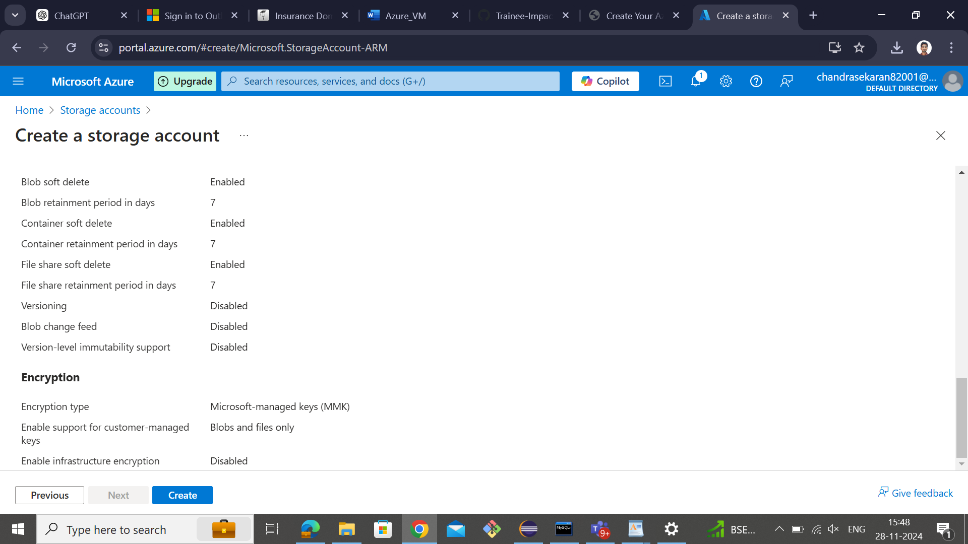

**Step 14:** Then it is showing the deployment of your storage account.

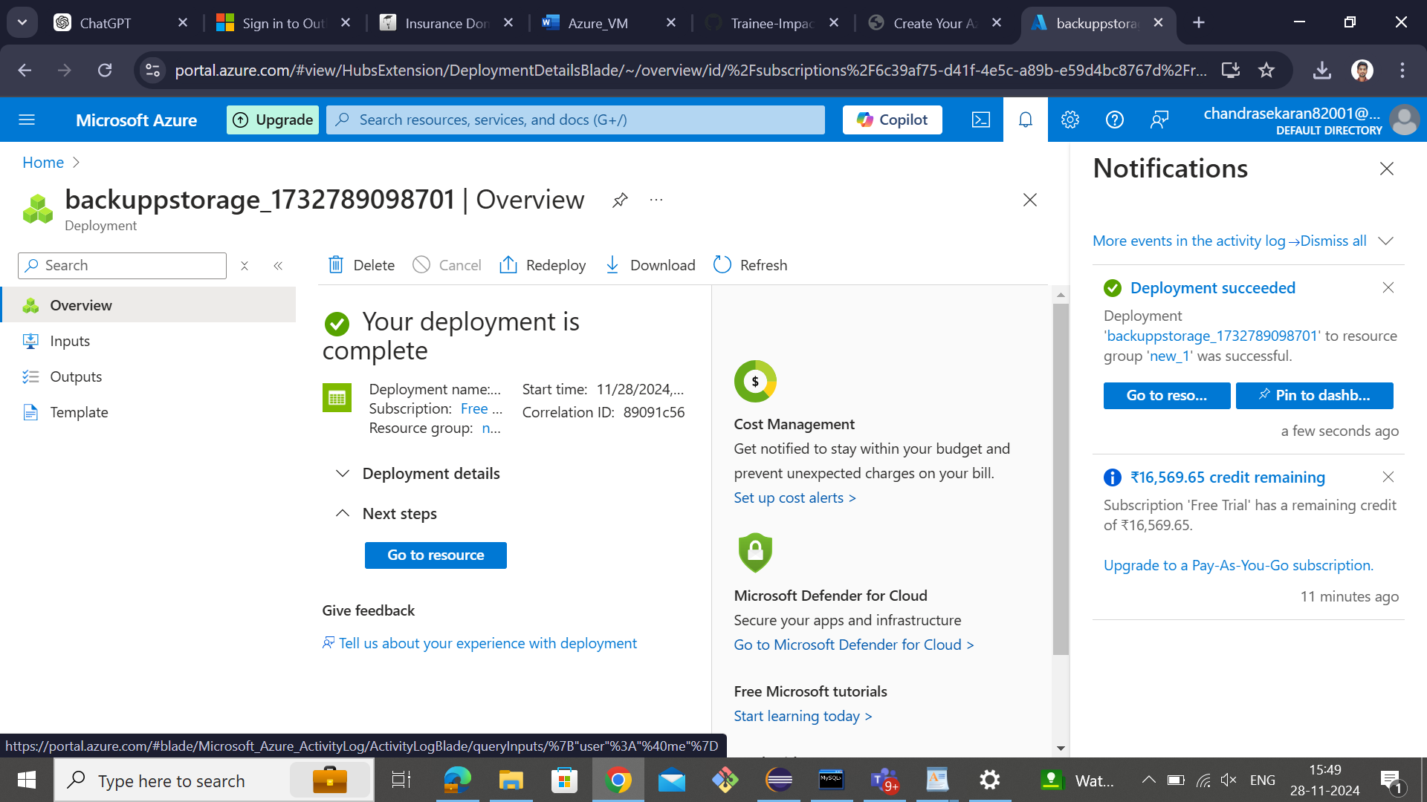

**Step 15:** If you want to upload any files. Select -> upload. In the top section.

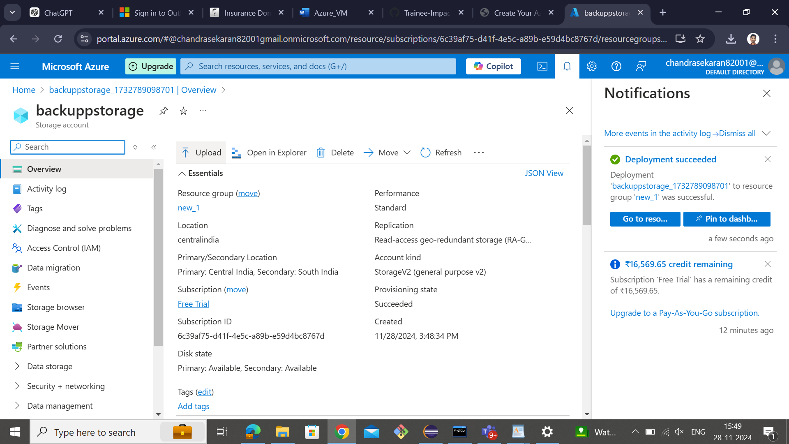

**Step 16:** Choose file from local storage and create->container to store the data.

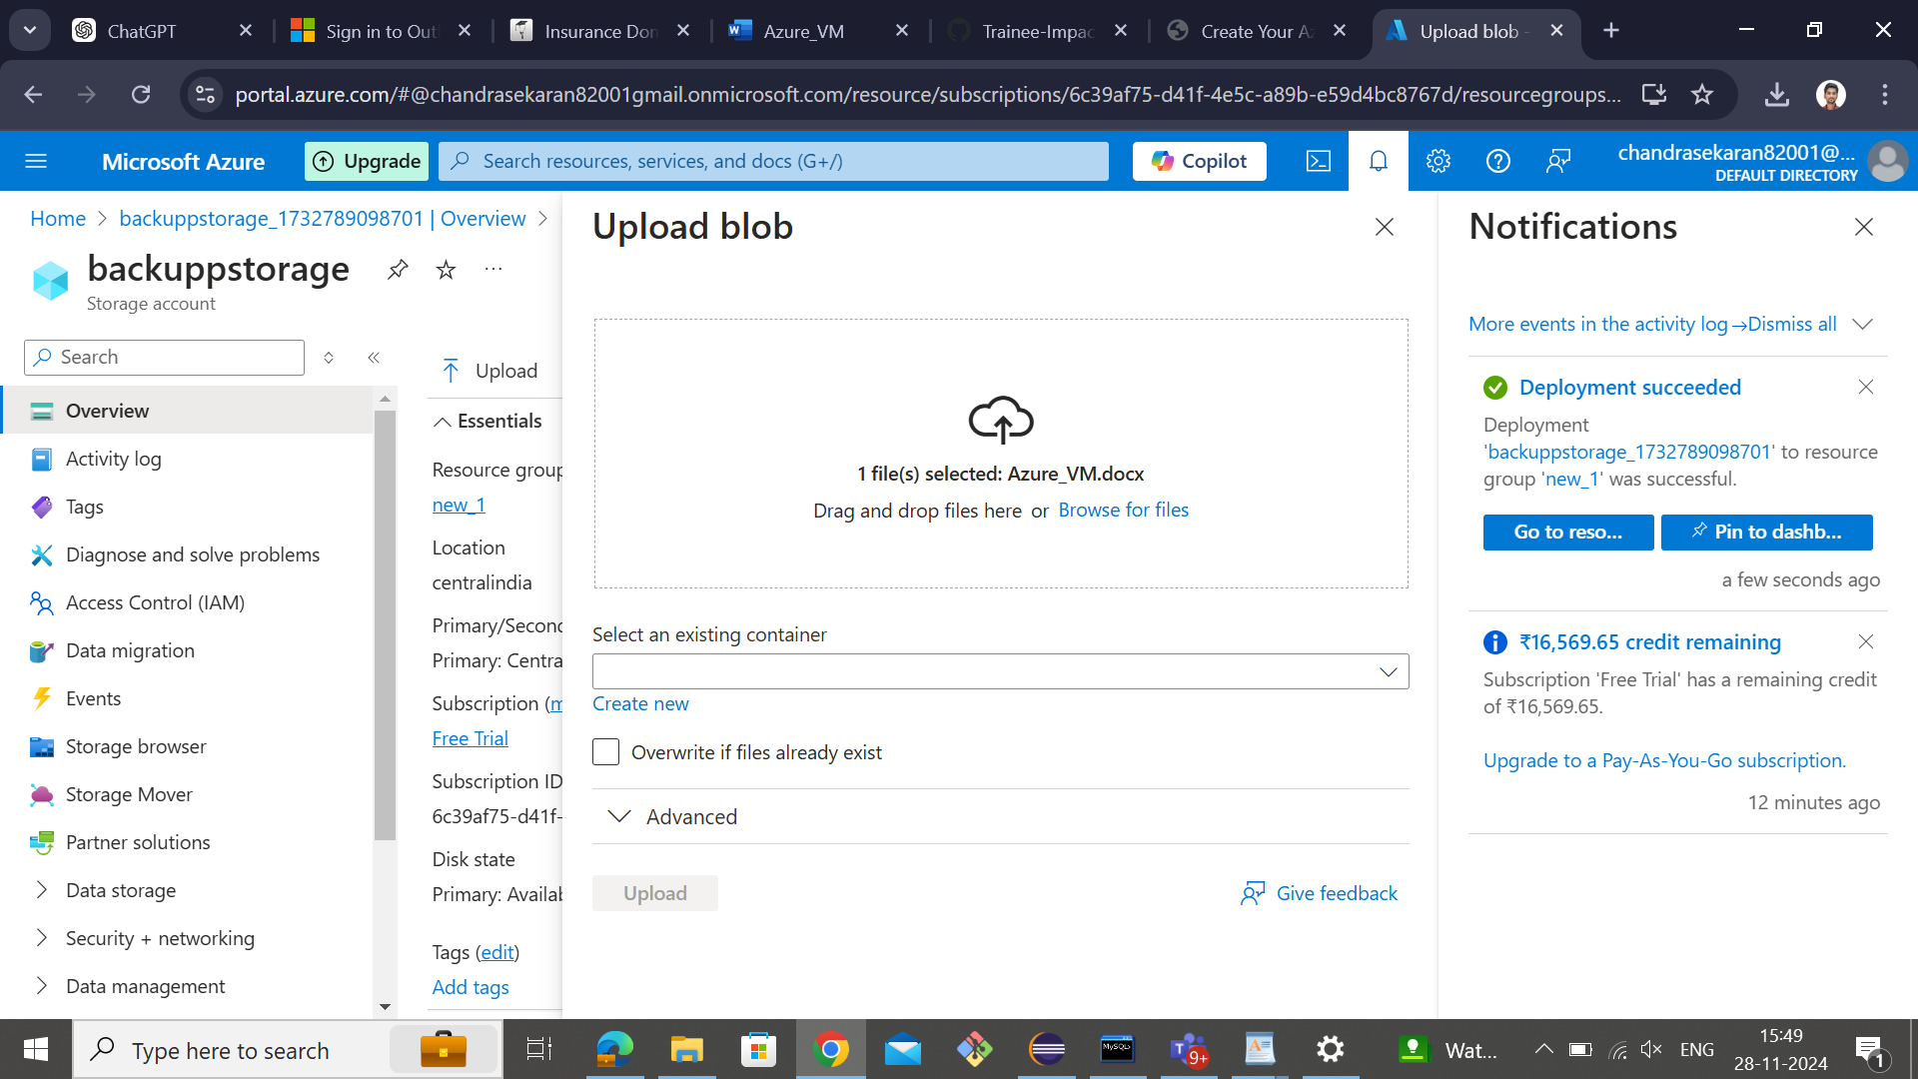

**Step 17:** It shows the file is uploading and uploaded in the right side or notification tab.

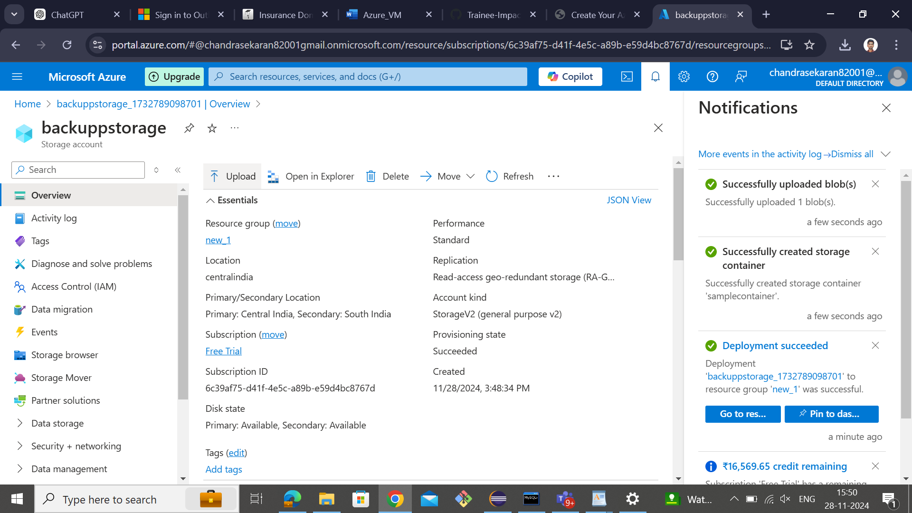

**Step 18:** Here you can see the output of the created container.

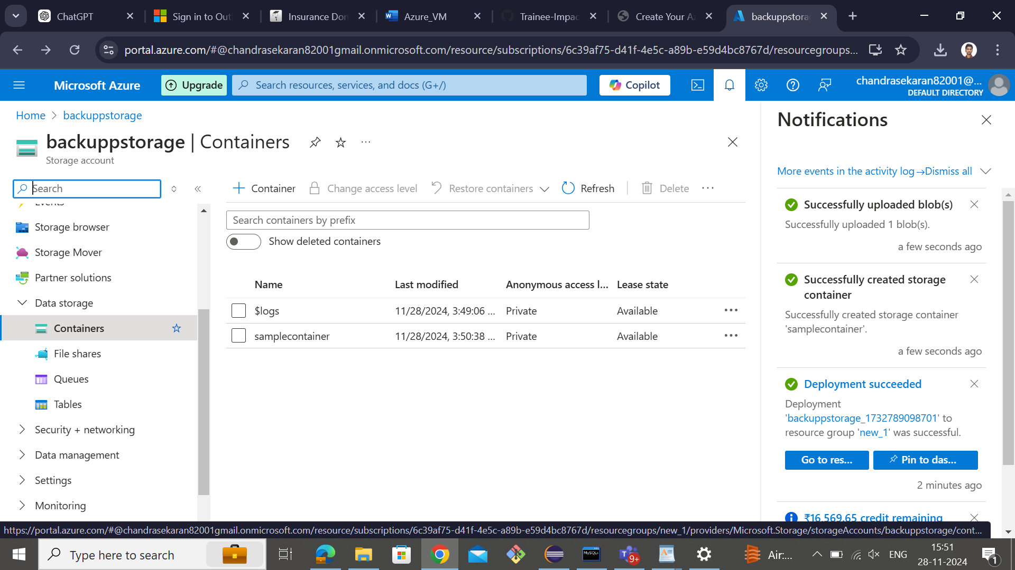

**Step 19:** Here is the uploaded file in it.

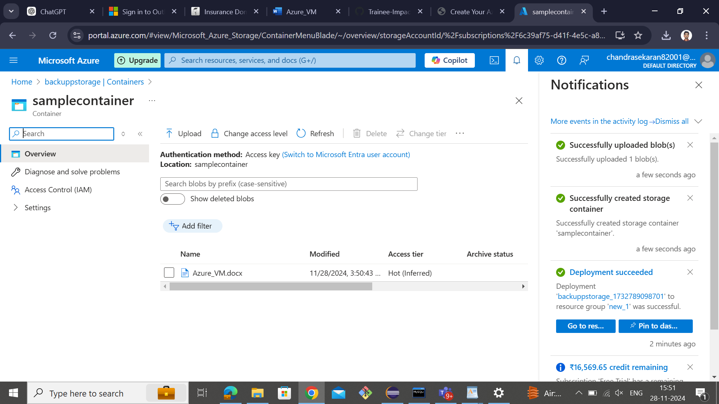

**Step 20:** After that, delete the file and storage account.

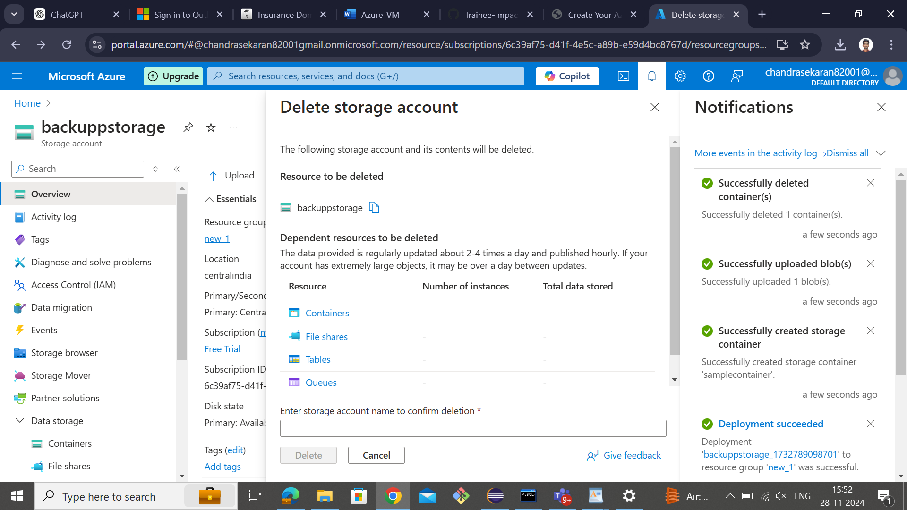

**Step 21:** Click->confirm delete.

